**Top 10 things to know about the new User Interface**

**(Don’t miss #10)**

1) We eliminated the multiple tabs across the top of the page. All primary activities can be done on a single page through a series of pop-up windows.

2) To create a new team, use the ‘Create new Team’ icon in the team navigation section in the left column.



3) Seeing your team hierarchy, making changes to your team name or discription as well as making changes to your parent team or even deleting a team is performed easily from the team area.

[A] To change the team name or description click the ‘Team Information’ icon

[B] To change the parent team association or to delete a team click on the ‘Team Setup’ icon

[C] The Team hierarchy is easily visible right under the team name

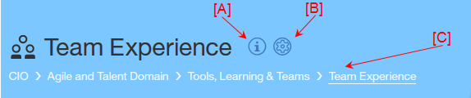

4) To update your bookmarks, formerly called important links, click on the ‘Team Bookmarks’ icon

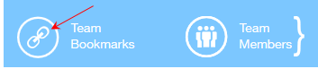

5) To display, edit, add team members as well as their Agile Roles, Allocation % and if they work Full Time or Part Time, click on the ‘Team Members’ icon. You will notice that all fields can be updated on the single team member line!



6) Results of your team’s most recently submitted maturity assessment is viewable right under your team information area.

[A] Your overall result is dispayed on a sliding scale from Initiating to Scaling. Information for an assessment in a draft status is not displayed here.

[B] Previous assessments can easily be selected

[C] Reviewing your action plan is as easy as clicking a button

[D] Easy to start a new assessment

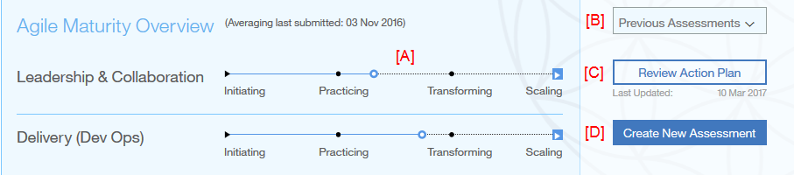

7) As you enter your iteration information into the Overview section on the right-hand side, your graphs will be updated as you enter and tab to the next field. *Assumption: The current system date is > or = to the iteration end date.*

8) If there are graphs in the Trends section that you do not want to display you can click on the ‘Filter Trends’ icon and deselect them from the list. This will apply to all teams you select from the team navigation area on the left-hand side. To bring the charts back, just click the icon and then check any graphs you want back in your view. . For now, these filter settings are only saved for the session, not long term, but it is in our plan.

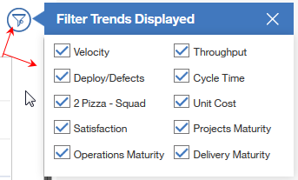

9) We have introduced the concept of ‘Person Days’ for each iteration. We compute the optimum team availability, in days, based on the number of work days (Mon-Fri) in an iteration from the iteration Start / End Date, the team member’s Allocation % and their Full Time, Part Time status. All you have to do is enter the total number of days your team members were unavailable during the iteration as a whole (red box below). If you make changes to your team structure during the course of an iteration you can reset the Optimum team availability value by clicking on the ‘Team Reset’ icon (arrow).

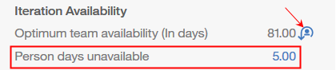

10) *Because of number 9 above, it is imperative that you as the iteration Manager ensure the following are correct for each team member:*

[A] Allocation %

[B] Average Work Week ( Full Time, Half Time, or Part Time expressed as a %, i.e if the team member works 2 full days a week it would be 40% with each full work day representing 20%.)

